GUIDE TO STANDARDISED HOME EXERCISE PROGRAMMES FOR PATIENTS WITH OSTEOARTHRITIS OF THE KNEE
- WARM-UP EXERCISES (FLEXIBILITY AND STRETCHING EXERCISES).
- Hamstring Stretch

- Lie down on your back on a firm surface.
- Loop a bed sheet around your foot.
- Use sheet to help pull and stretch leg up for 20 seconds and relax
- Repeat the procedure 2 times.
- Switch to the other leg.

Duration of Number of Times per
Pull: 20 seconds repetitions: 2 times week: 3 times

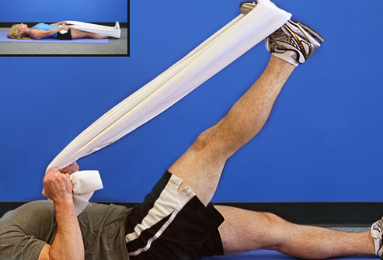
Exercises for OA of the Knee (Andrew, 2011).
- Calf Stretch
- Using a chair for balance, bend your right leg.
- Step back with left leg, slowly straightening it behind you
- Press left heel towards the floor and feel the stretch on the back of your left leg and hold the stretch for 20 seconds and repeat the procedure one more time.
- Switch to the other leg.

Duration of Number of Times per
Hold: 20 seconds repetitions: 2 times week: 3 times

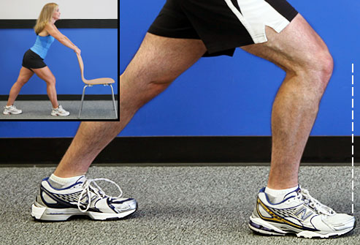
Exercises for OA of the Knee (Andrew, 2011).
- MAJOR EXERCISES

Straight Leg Raise
- Lie on the floor and prop your back up on your elbows.
- Bend your left knee, keeping foot on floor.
- Keep the right leg straight with toes pointed up.
- Tighten thigh muscles of your right leg
- Slowly and smoothly use your thigh muscles, not your back, to raise your right leg.
- Hold your right leg there for five seconds.
- With thigh still tight, slowly lower leg to ground and relax.
- Repeat 10 times in two sets
- Switch to the other leg

Duration of Number of Number of Times per
hold: 5 seconds repetitions: 10 times sets:2 sets week:3 times

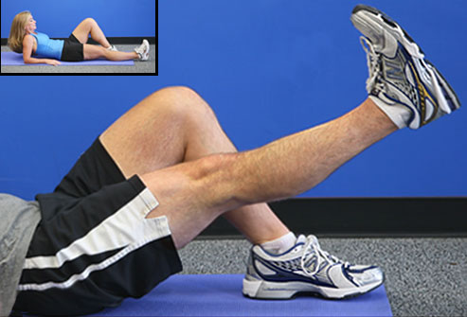
Exercises for OA of the Knee (Andrew, 2011).

Quad Set
- Start by lying on your back on a firm surface.
- Keep both legs on ground, relaxed.
- Simply tighten the thigh muscles, also called the quadriceps, of one leg
- Hold the leg tense for five seconds, as seen in right-hand photo below.
- Repeat 10 times with rest after each contraction.
- Do two sets of 10contractions each
- Then, switch to other leg.

Time of Number of Number Times
Hold: 5 seconds repetitions:10 times of sets:2 sets per week:3 times

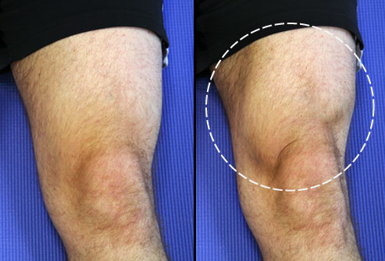
Exercises for OA of the Knee (Andrew, 2011).

Pillow Squeeze
- Squeeze knees together, squishing pillow between them. Hold for five seconds. Relax.
- Repeat 10 times; rest, then do another set of 10.
Time of Number of Number Times
Hold:5 seconds repetitions:10 times of sets:2 sets per week:3 times
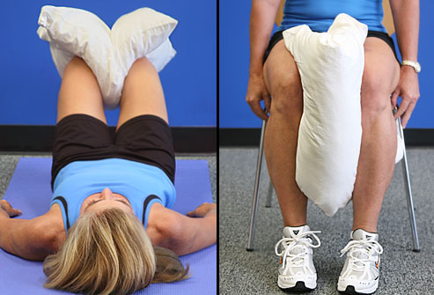
Exercises for OA of the Knee (Andrew, 2011).

D. Heel Raise
- Hold back of chair for support and stand straight and tall.
- Lift heels off ground and rise up on toes of both feet and hold for five seconds.
- Slowly lower both heels to ground.
- Repeat 10 times; rest and do another 10
Time of Number of Number Times
Hold: 5 seconds repetitions: 10 times of sets:2 sets per week:3 times
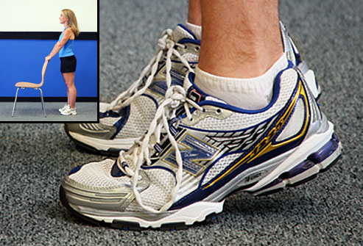
Exercises for OA of the Knee (Andrew, 2011).

One Leg Balance
- Your goal is to do this hands-free.
- Steady yourself while standing with your hands on a chair as shown below.
- Shift your body weight to one leg but do not lock your knee straight.
- Slowly raise the other foot off the ground, balancing on your standing leg.
- Remove your hands from the chair and hold for 5 seconds.
- Lower raised foot to the ground and repeat 10 times.
- Switch legs.
Time of Number of Number Times
Hold:5 seconds repetitions:10 times of sets:2 sets per week:3 times

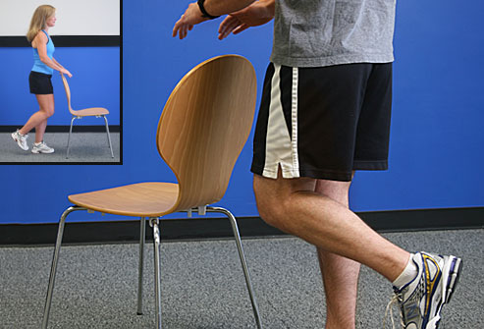
Exercises for OA of the Knee (Andrew, 2011).

Step Ups
- Face a stable step, both feet on the ground. Step up with your left foot.
- Follow with your right foot. Stand on top, tall and with both feet flat.
- Climb down in reverse: right foot down first, then left. Do 10 times. Rest, then repeat another 10 times.
- Repeat, starting with right leg first.
Number of Number Times
repetitions: 10 times of sets: 2 sets per week :3 times

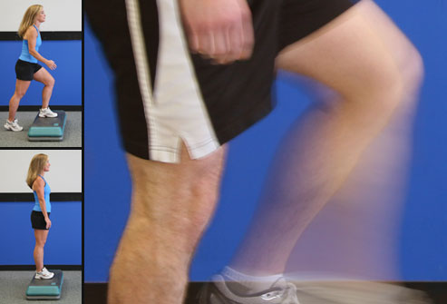
Exercises for OA of the Knee (Andrew, 2011).
- Quadriceps Strengthening Exercise

Procedure:
- Sit on a high chair with the feet not touching the floor
- “The 10 repetition maximum” which is the maximum weight that can be lifted correctly through a full arc of knee extension for 10 repetitions is determined using weight bags for each individual.
- Perform three (3) set of quadriceps strengthening exercise using weight bag following the under listed guidelines by DeLorme and Watkin, 1948.
First set of 10 repetitions ----------------------------Use ½ of 10 repetition maximum
Second set of 10 repetitions--------------------------Use ¾ of 10 repetition maximum
Third set of 10 repetitions----------------------------------Use 10 repetition maximum

